PROJECT REPORT CSE428

Virtual Therapy Assistant


Section: K23DC
Submitted to: Tushar Gupta
Submitted by:-

Sr. No. | Registration No | Name of Students | Roll No | Sec
1 | 12316644 | Mokshagna | 32 | K23DC
2 | 12320426 | Fanithsai | 65 | K23DC
3 | 12320905 | Sai Teja | 38 | K23DC

Content
INTRODUCTION… 2
VIRTUAL THERAPY ASSISTANT… 2
Technology Used…………………………………………………………………... 2
Features & Benefits 4
Challenges Faced & Solutions… 4
Screenshots /Output Results… 5
GitHub Link 6
Future Scope 7
CONCLUSION 9
Role of Each Member 11

INTRODUCTION:

The stock market is a dynamic financial marketplace where shares of publicly listed companies are bought and sold. It plays a crucial role in the economy by enabling businesses to raise capital and offering investors opportunities to grow wealth. Through exchanges like the NYSE and NASDAQ, investors can trade equities, bonds, and other securities. Understanding stock market trends, risks, and investment strategies is key to making informed financial decisions.
- Administrative Support:
Manages documentation, compliance, and daily coordination.
Ensures efficient back-office operations in stock trading.
- Client Communication:
Handles regular interaction and updates with clients.
Delivers market insights, trade confirmations, and support.
- Data Management:
Organizes and analyzes market and trading data.
Aids informed decision-making through accurate reporting.

PROBLEM STATEMENT:

Title:
Enhancing Efficiency and Trust in Stock Marketing through Streamlined Operations and Data-Driven Strategies.
Background:
Stock marketing involves the buying and selling of company shares through stock exchanges. It plays a crucial role in capital generation, wealth creation, and economic growth. However, the industry heavily relies on accurate data, client trust, and efficient administrative workflows. As the volume of trades and client expectations grow, firms face challenges in managing operations, communication, and compliance, exposing critical gaps that need to be addressed
Problem:
Despite its critical role in the financial ecosystem, the stock marketing sector struggles with outdated administrative systems, inconsistent client communication, and fragmented data management. These inefficiencies lead to delayed decision-making, reduced client satisfaction, and increased operational risks.

Technology Used:

Programming Languages:
- Python: Widely used for its simplicity and extensive libraries, particularly in natural language processing (NLP) and machine learning.
- Java: Commonly employed for building robust backend systems and applications.
- Html: HTML is the backbone of web development, providing the structure for web pages.
- Tailwind CSS: Tailwind CSS is a utility-first CSS framework that allows developers
to style their applications quickly and efficiently.

Frameworks:
  - NET: Used to build secure, scalable trading and portfolio management systems.
Supports real-time data processing, client interfaces, and backend operations.
  - TensorFlow: Applies machine learning to predict stock trends and automate trades.
Processes large datasets for market analysis and risk assessment
  - Platforms:
Google Cloud: Provides scalable infrastructure for real-time data processing and storage.
Supports stock analytics, AI-driven insights, and secure trading platforms.
Framework:
ChatGPT: Stock marketing involves the buying and selling of company shares through stock exchanges.
It enables capital growth, investment opportunities, and reflects market sentiment.
- Grammarly: Grammarly is an AI-powered writing assistant that helps improve grammar, clarity, and tone.
It ensures professional, error-free communication in emails, reports, and documents.
- Mind Meister: MindMeister is an online mind mapping tool used for brainstorming, planning, and visual thinking.
It helps organize ideas, track strategies, and enhance team collaboration in real time.

Features and Benefits:

Feautures:
- Buying & Selling of Shares
Facilitates trading of publicly listed company stocks.
- Market Transparency
Real-time data on prices, volumes, and company performance.
- Investment Diversification
Access to various sectors, industries, and global markets.
- Regulatory Framework
Governed by financial authorities ensuring fair practices.

Benefits:
- Wealth Creation
Long-term capital appreciation through stock investments.
- Dividend Income
Earnings from company profits distributed to shareholders.
- Ownership in Companies
Shareholders gain partial ownership and voting rights.
- Economic Growth
Helps businesses raise capital and supports national development.

Challenges Faced & Solutions:

Technical Challenge:
Data Security and Compliance:
Challenge: Stock marketing platforms handle sensitive financial data and high-value transactions, making them prime targets for cyber threats. Ensuring end-to-end data security, encryption, and compliance with financial regulations (like SEBI, SEC, GDPR) is a complex and ongoing challenge.
Any breach or non-compliance can result in financial loss, legal consequences, and damage to client trust.
Solution:
- Encryption: Encryption is the process of converting sensitive data into a secure code to prevent unauthorizedaccess.In stock marketing, it protects client information, trade data, and financial transactions from cyber threats.

2. Access Controls: Access controls regulate who can view or modify trading systems, client data, and financial records.They help prevent unauthorized access, ensuring only verified users can perform sensitive operations..

Screenshots/Output Results:

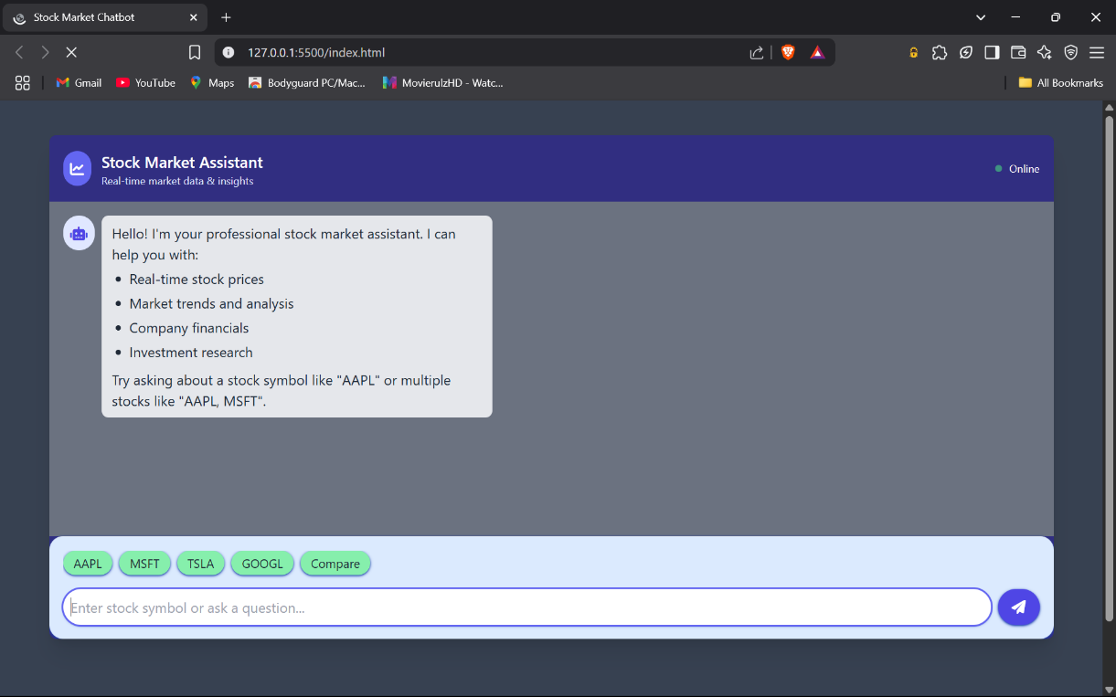
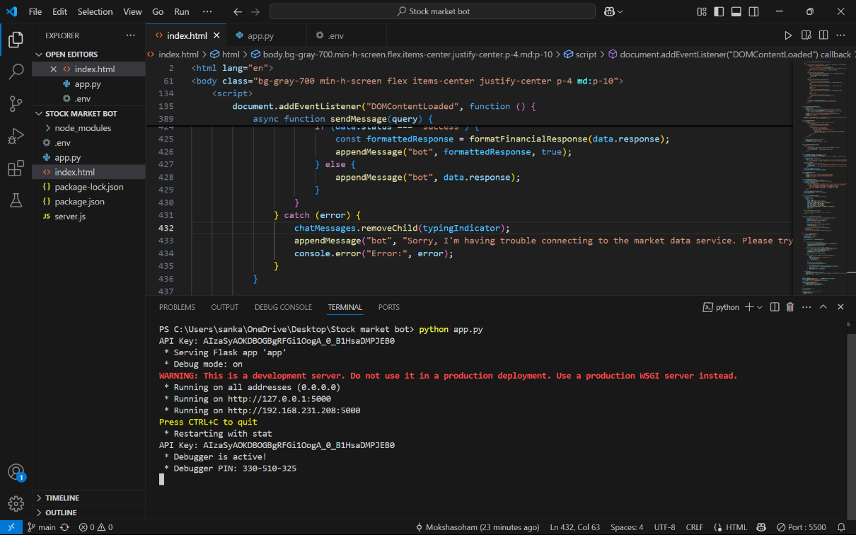

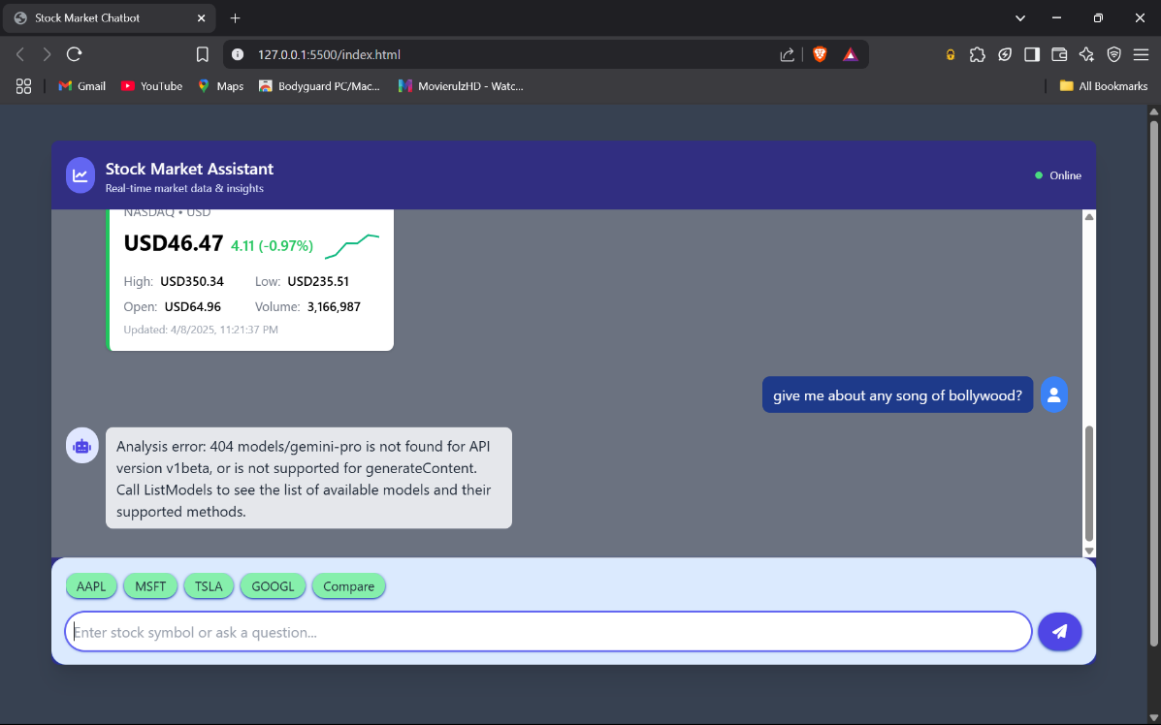
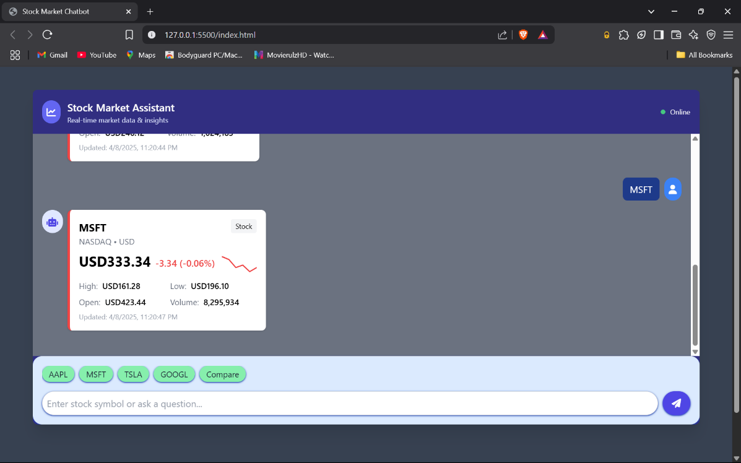

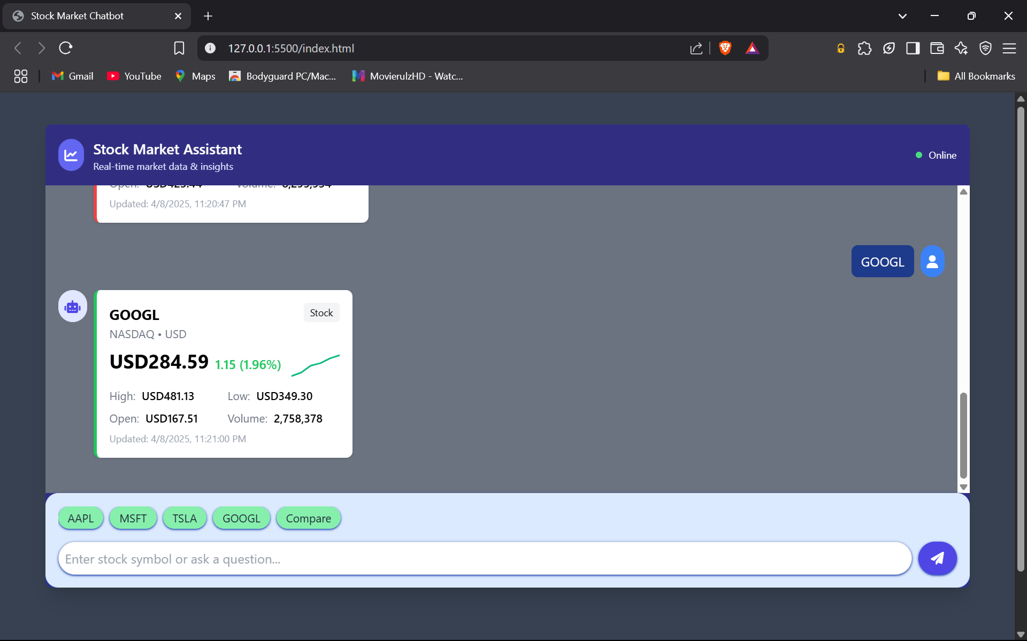

Git Hub Link:

Git hub link Repo : https://github.com/Mokshasoham/Stock-Market-Chatbot

Future Scope:

Integration of Advanced AI and Machine Learning:
  - Scope:
More advanced AI algorithms will be used by virtual therapy assistants in the future to evaluat e client data and forecast trends in mental health, allowing for individualized treatment regime
.

Impact:
More proactive interventions and individualized treatment approaches depending on the need
s of each client may result from this.

Enhanced Natural Language Processing (NLP):
  - Scope :
By enhancing their natural language processing (NLP) skills, virtual assistants may better co mprehend and reply to customer questions, resulting in more supportive and organic interacti ons.

Impact :
By improving user experience and engagement, this would help clients feel more connected a
nd understood.

Conclusion:

A major development in the field of mental health treatment, the virtual therapy assistant meets
the increasing need for easily available, effective, and individualized therapeutic help.
Incorporating cutting-
edge features like data analytics, secure messaging, appointment scheduling, and billing mana gement not only relieves therapists of administrative duties but also gives clients the ability to a ctively participate in their mental health journey .
The overall experience is further improved by using HTML and Tailwind CSS to create user- friendly interfaces that make interactions simple and aesthetically pleasing.
Virtual therapy assistants improve client outcomes and operational efficiency in therapy practice s, increasing the effectiveness and accessibility of mental health treatment for those in need.
These assistants have enormous potential to change the therapeutic landscape as technology
develops, opening the door to a more supportive and linked mental health treatment setting.

ROLE OF EACH MEMBERS:

👤 Mokshagna: Frontend & Git hub Repository Responsibilities to present:
    - Explain the HTML + Tailwind CSS design.
    - Talk about the responsive layout and user-friendly features like:
      - Chat bubbles for user/bot.
      - Scrollable chat box.
      - Send message on "Enter" key press.
    - Mention how the frontend connects to the backend via fetch API.
    - Optional: If added, show extra features like quick-reply buttons or animations.

👤 Fanith sai: Backend & API Integration Responsibilities to present:
      - Explain the Flask backend setup:
        - Routes (/chat endpoint),
        - Receiving and processing user messages.
      - Describe how you used the Google Gemini API:
        - Loading the API key securely from .env,
        - Configuring the model,
        - Handling API errors (like rate limits).
      - Mention any logic added for interactive, point-wise responses.

👤 Sai Teja: Debugging, Testing, and Final Integration Responsibilities to present:
◻ Development Challenges & Error Handling:
- Talk about common issues faced during development:
  - API quota exceeded errors (HTTP 429) — how it was debugged and
what it meant.
  - Handling .env and environment variable issues.

